

SINUHE

The HIEROTYPER

　INSTALLATION GUIDE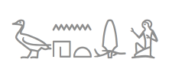

I made [the website here](http://somiyagawa.github.io/SINUHE-the-Hierotyper/?fbclid=IwAR0K_yciZQ2oqkhBG_cbXSvEaAUmVZRSZwE3OjlNFcNEFT3v4I4QhODR1EU). The website is more updated.



*HieroJIS and Marwan’s font were combined and named SINUHE*

# HOW TO USE SINUHE - - - - X

Download [SINUHE SUITE](http://somiyagawa.github.io/SINUHE-the-Hierotyper/?fbclid=IwAR0K_yciZQ2oqkhBG_cbXSvEaAUmVZRSZwE3OjlNFcNEFT3v4I4QhODR1EU) or from GitHub repo (<https://github.com/somiyagawa/SINUHE-the-Hierotyper>). (from here, you can follow [this video](https://www.youtube.com/watch?v=EAg2l6Wx7oA))

* Install [Google Japanese input](https://tools.google.com/dlpage/japaneseinput/eula.html?platform=win)
* Set up the Google Japanese Input on System Preferences or Control Panel. For Mac Users, use Full-Width Alphanumeric.
* I recommend you to set the ctrl + SPACE shortcut
* Open Google Japanese Input’s Dictionary Tool
* Import JISBasicDictSet.txt or [hierojis16112016.txt](https://github.com/somiyagawa/SINUHE-the-Hierotyper/blob/master/hierojis16112016.txt) on Dictionary Tool (pls ignore errors)
* Turn on Google Japanese Input. Add it on your Keyboard and Language.
* If you cannot do, please watch [this video](https://www.youtube.com/watch?v=EAg2l6Wx7oA) (for WIN users, I will help you in person, please send an email).
* Install EgyptianHiero included in SINUHE SUITE
* Change the font to EgyptianHiero
* If you type it on MS Word, make sure “Ligature” is on! Font → Advanced → enable all the ligatures

The easiest way is to follow and imitate [this video](https://www.youtube.com/watch?v=EAg2l6Wx7oA).

“

“When I’m old and dying, I plan to look back on my life and say ‘wow, that was an adventure,’ not ‘wow, I sure felt safe.'”

### Tom Preston-Werner (President, GitHub)

”

Four Noble Inputs

1. transliteration of a word
2. categories like MAN, GOD, MAMMAL (capital letter)
3. transliteration of phonograms
4. Gardiner’s code such as A01

For Mac Users, you can change the input system between Hieroglyphs and Deutsch (or English or other languages) with cmd/ctrl and SPACE, however, you have to set up on System Preferences.

- Editing hieroglyphs on Pages with underlines and colours (<https://www.youtube.com/watch?v=RmBgn9W5LtM&feature=share>)

- Inputting Hieroglyphs in group writing on Excel (<https://www.youtube.com/watch?v=qokqLzGGD7Y>)

- Demo video of inputting hieroglyphs in a quadrat on Pages (<https://www.youtube.com/watch?v=Zx0A3A7K-dQ&feature=youtu.be>)

- Demo video of web font displayed on Chrome and searching Hieroglyphs on Google ( <https://www.youtube.com/watch?v=dEaCiduB2OA&feature=youtu.be>)

Break: Variety of Typewriters and Grammatology

* See [English typewriter](https://www.youtube.com/watch?v=FkUXn5bOwzk)
* See [Japanese typewriter](https://www.youtube.com/watch?v=JHJhah1c-K0)
* See [Chinese typewriter](https://www.youtube.com/watch?v=M77DxXRI014)
* See the slides from Cambridge

Merits of Google Japanese Input or Mozc as an input engine:

* Good to input logograms and determinatives as well as phonograms
* extensible
* works on Windows, Mac and Linux (mozc)
* Developer’s version (mozc). You can change the code

# JOIN THE DEVELOPER TEAM!

- - - - X

Make your GitHub account [here](https://github.com/)

GitHub is the easiest VERSION MANAGEMENT TOOL

MANY digital humanities projects are using github for the platform of team work such as

* [Perseus Digital Library](http://www.perseus.tufts.edu/hopper/) (its [GitHub](https://github.com/PerseusDL))
* [Coptic SCRIPTORIUM](http://copticscriptorium.org/) (its [GitHub](https://github.com/CopticScriptorium))
* [ANNIS](http://corpus-tools.org/annis/) (its [GitHub](https://github.com/korpling/ANNIS), also see <http://copticscriptorium.org/>)

Download [GitHub Desktop](https://desktop.github.com/)

After this, I will teach you in the workshop.

# How to Use it on Microsoft Word

Change the font to EgyptianHiero

See this: <https://youtu.be/WswOJlfSbR4>

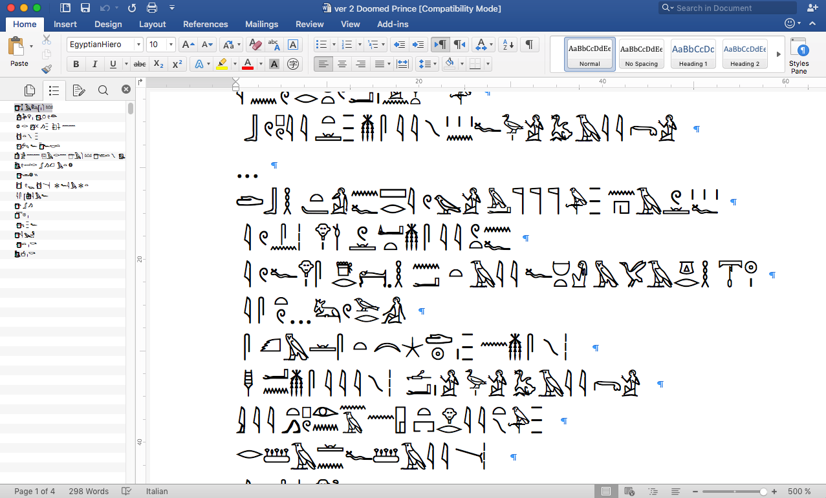

For typing it on Word, please change the font settings like this:

Please select all the letters, open the font window, and make all the ligatures valid. 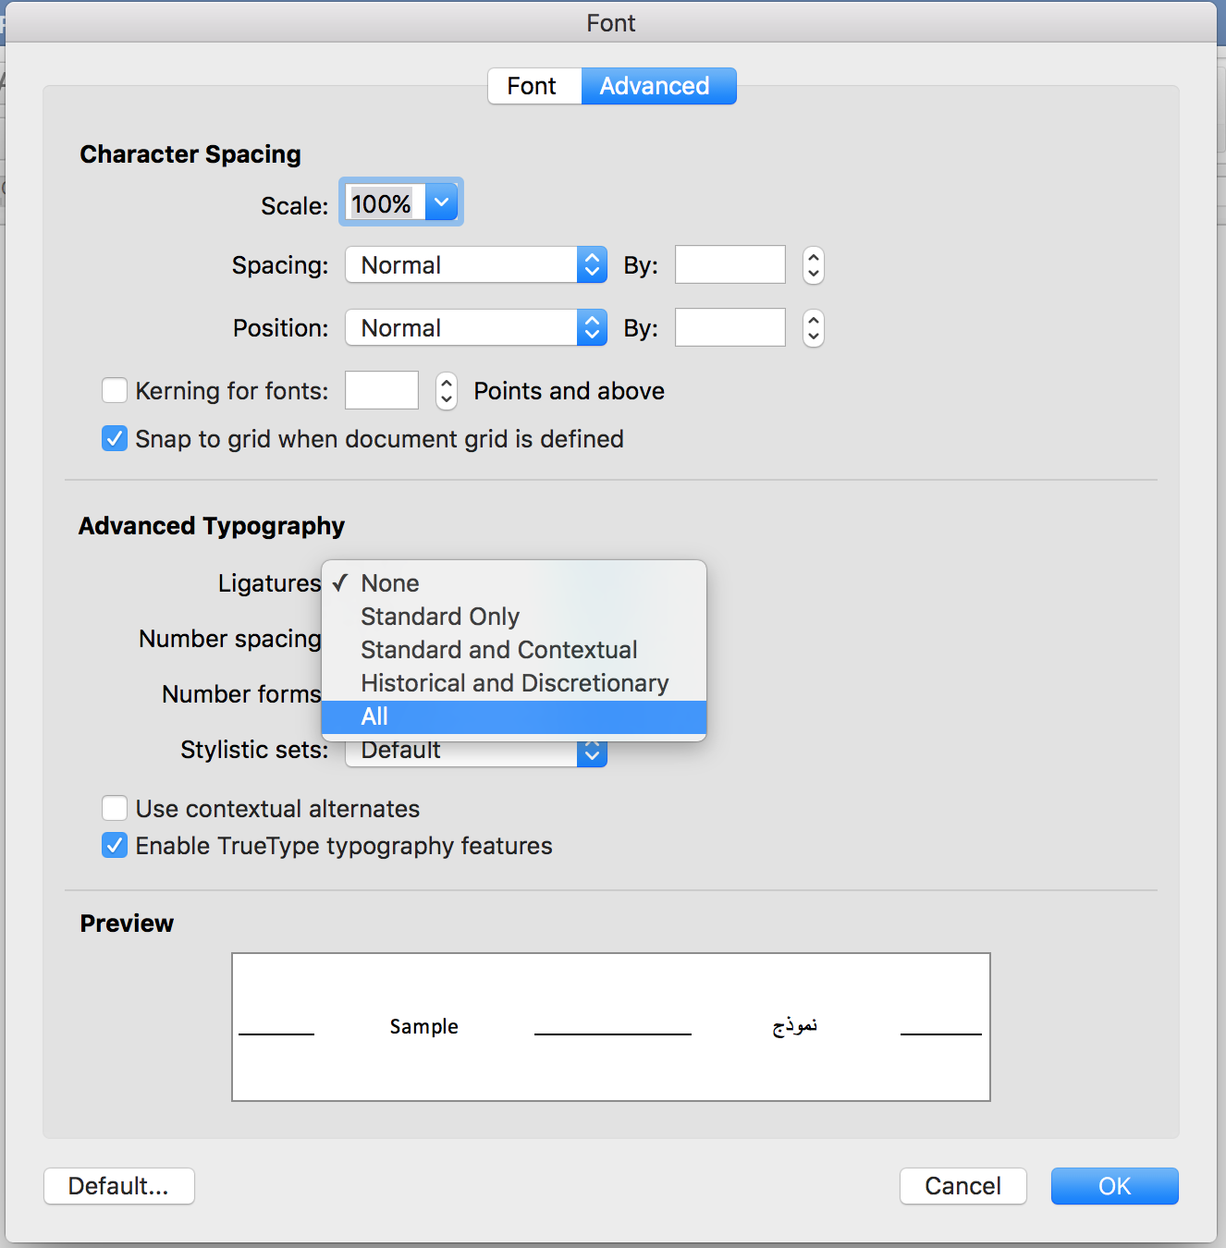

# How to Use it on your browser

Please change the font of your browser into EgyptianHiero in your browser settings

